

24ADC001- BUSINESS INTELLIGENCE

--------------------------------------------------

2026-2027
LAB RECORD

DEPARTMENT OF ARTIFICIAL INTELLIGENCE AND DATA SCIENCE
Name: Akhil C

Roll no: 24BAD007

INDEX
Expt. No | Title of the Experiment | Page No | Total Marks | Faculty Signature
1. | Explore the interface and basic features of the BI tool
2. | Load and visualize a sample dataset.
3. | Import a dataset into the BI tool. And Cleanse data by handling missing values, outliers, and  inconsistencies.
4. | Transform data to suit BI reporting requirements and Design a dashboard with  key performance indicators (KPIs).
5. | Develop interactive dashboards for dynamic data exploration.
6. | Integrate data from various sources for comprehensive analysis
7. | Implement advanced chart types (treemaps, heatmaps, etc.).
8. | Apply BI tools for forecasting and predictive analytics.

Average marks Faculty Signature

EXPT NO:1 | EXPLORE THE INTERFACE AND BASIC FEATURES OF BI Tool
DATE: 10.07.2026

PRE-LAB QUESTIONS (PROVIDE BRIEF ANSWERS TO THE FOLLOWING QUESTIONS)

- What is the purpose of Business Intelligence (BI) tools like Tableau and Power BI?
BI tools help users analyze data, create visualizations, generate reports, and make better business decisions based on data.

- List any three common data sources that Tableau and Power BI can connect to.
Microsoft Excel
CSV Files
SQL Databases

- What is a dashboard in BI, and how is it different from a single chart?
A dashboard is a collection of multiple charts and KPIs displayed on one screen, while a single chart represents only one aspect of the data.

- Define the following terms:
  - Visualization
  - KPI
  - Data Filter

Visualization
A graphical representation of data using charts, graphs, or maps.
KPI
Key Performance Indicator; a measurable value used to evaluate performance.
Data Filter
A feature used to display only selected data based on specified conditions

- Why is it important to clean and transform data before visualization?
Cleaning and transforming data removes errors, missing values, and inconsistencies, ensuring accurate analysis and reliable visualizations.

- What kind of chart would you use to analyze stock price trends over time?
A Line Chart.

- Explain the role of slicers in Power BI and filters in Tableau.
Slicers in Power BI and filters in Tableau allow users to interactively display only the required data based on selected values

- What does a calculated field or measure do in BI tools?
It performs calculations on existing data to create new values or metrics for analysis.

- What are the advantages of using interactive dashboards for financial data analysis?
Easy data exploration
Real-time insights
Better decision-making
Interactive filtering
Improved trend analysis
- Which function would you use to find the absolute difference between predicted and actual stock prices?
The ABS() function.

IN-LAB EXERCISE:
Objective:
To understand the basic interface, data import process, and fundamental visualization capabilities of Tableau and Power BI using a stock prediction dataset, and to explore their usefulness in analyzing financial data.

Tools Required:
- Tableau Public / Tableau Desktop
- Power BI Desktop
- Sample Dataset (CSV/Excel) containing:
Date, Stock Name, Open, Close, High, Low, Volume, Predicted Price

Exercise Steps:
Part 1: Working with Tableau
- Launch Tableau and connect to the stock prediction dataset.

Explore the Interface:
  - Understand components like Data Pane, Sheets, Marks Card, and Dashboards.

Create Basic Visualizations:
  - Line Chart: Show Close Price over time.
  - Scatter Plot: Plot Volume vs. Predicted Price.
  - Highlight Table: Display Predicted Price by stock.

Apply Filters:
  - Add filters for Stock Name and Date Range.

Create Calculated Field:
  - Calculate prediction error as |Predicted - Close|.

Design a Basic Dashboard:
  - Combine your charts into one interactive dashboard.

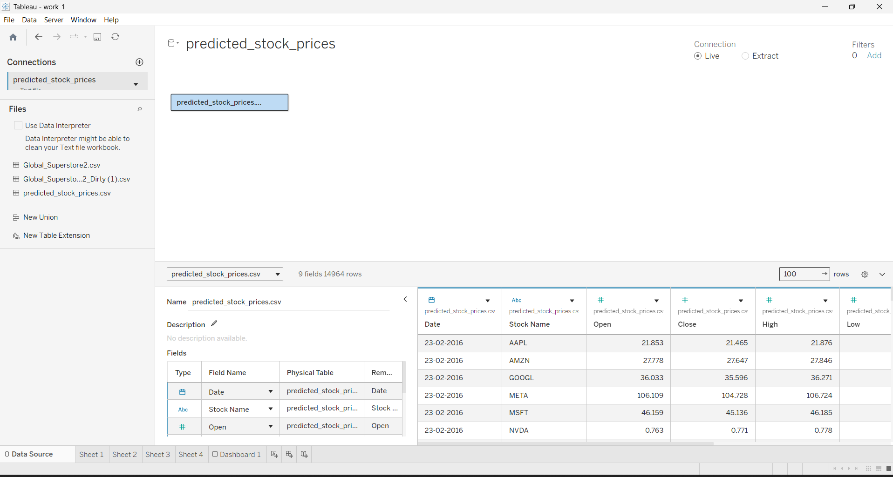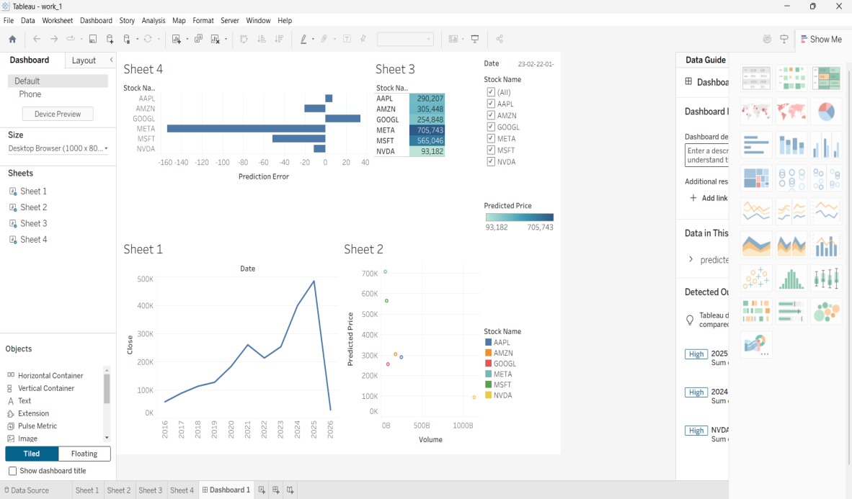

Part 2: Working with Power BI
- Open Power BI Desktop and import the same dataset.

Explore the Interface:
  - Familiarize with Fields Pane, Visualizations Pane, Report View, Data View.

Create Basic Visualizations:
  - Line Chart: Trend of Close Price over time.
  - Bar Chart: Compare Predicted Price vs. Close Price.
  - Card (KPI): Display average prediction error.

Use Filters and Slicers:
  - Filter data based on Stock Name and Date.
- Create a Simple Measure using DAX:
  - Example: Prediction Error = ABS(Predicted - Close)

Build a Report Page:
  - Arrange visuals in a single interactive page.

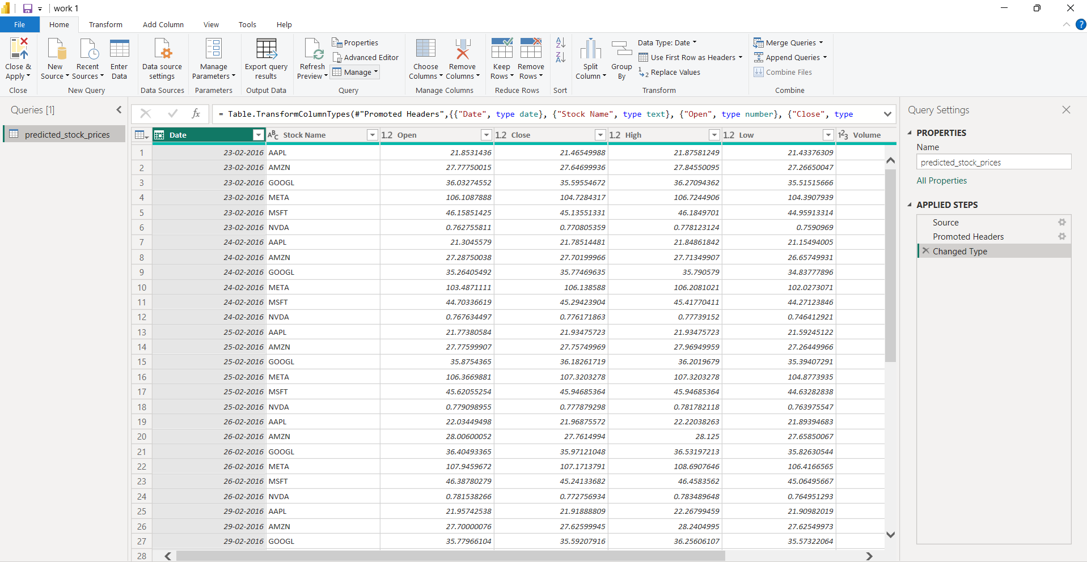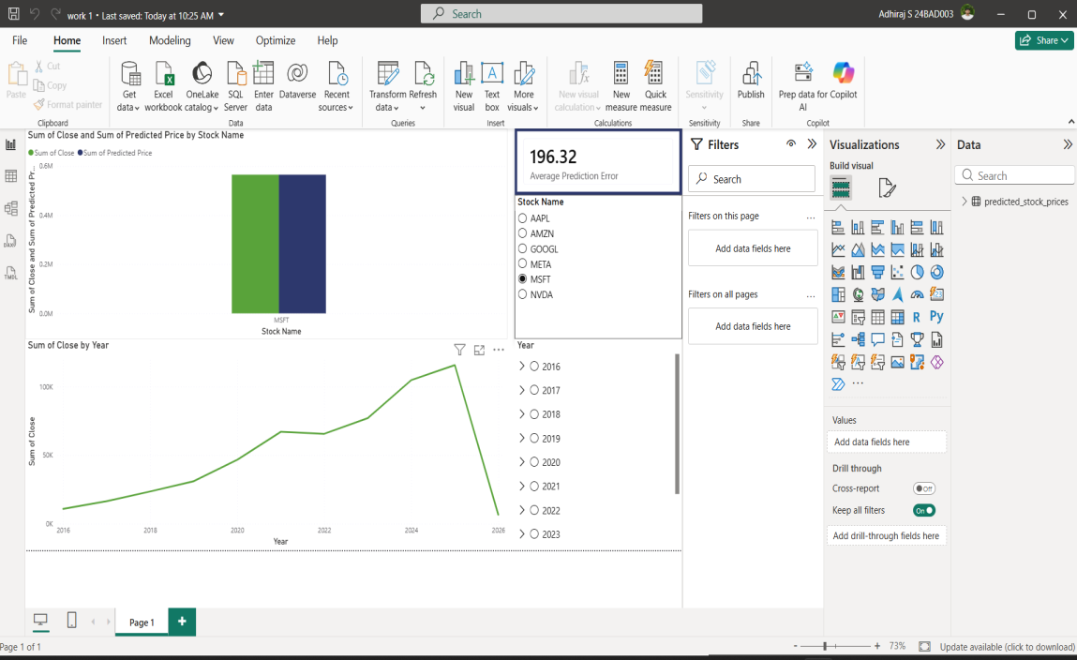

POST-LAB QUESTIONS (PROVIDE BRIEF ANSWERS TO THE FOLLOWING QUESTIONS)
- Describe your experience with the Tableau interface. What components did you interact with?
I explored the Data Pane, Sheets, Marks Card, Filters, Dashboard, and Toolbar. These components helped me create and customize visualizations.

- How did you import the dataset into Tableau and Power BI?
I selected Connect to Data, chose the Excel/CSV file, loaded the dataset, and imported it into the workspace.

- What types of visualizations did you create in both tools? List at least two per tool.
Tableau
- Line Chart
- Scatter Plot
- Highlight Table
Power BI
- Line Chart
- Bar Chart
- KPI Card

- How did you calculate the prediction error, and how was it displayed in your dashboard?
I calculated the prediction error using:
Prediction Error = ABS(Predicted Price − Close Price)
The result was displayed as a KPI card and used in charts.

- Which filtering or slicing techniques did you apply, and what insights did they reveal?
I applied filters/slicers for Stock Name and Date. They helped compare stock performance and analyze trends for selected periods.

- Compare the process of creating a line chart in Tableau vs. Power BI. What differences did you notice?
In Tableau, I dragged fields onto Rows and Columns to create the chart. In Power BI, I first selected the Line Chart visual and then assigned fields to the Axis and Values sections. Power BI's process was more visual, while Tableau relied more on drag-and-drop.
- How did you organize the dashboard in Tableau and Power BI? What key elements did you include?
I arranged charts, KPI cards, filters, and titles neatly in a single dashboard for easy analysis and interaction.

- Which tool (Tableau or Power BI) did you find more user-friendly for financial data visualization, and why?
I found Power BI more user-friendly because it has an intuitive interface, built-in visualizations, and simple drag-and-drop functionality.

- What challenges did you face while creating visualizations or dashboards?
It helps analyze stock market trends, monitor KPIs, detect prediction errors, build dashboards, and support informed financial decision-making.

- How can the knowledge gained from this lab be applied to real-world financial data analysis?
I arranged charts, KPI cards, filters, and titles neatly in a single dashboard for easy analysis and interaction.

ASSESSMENT

Description | Max Marks | Marks  Awarded
Pre Lab Exercise | 5
In Lab Exercise | 10
Post Lab Exercise | 5
Viva | 10
Total | 30
Faculty Signature

